**UE20CS352 - OOADJ**

**Lab Assignment - 3**

**Activity and State Diagram**

**SRN**: PES2UG20CS389

**Name**: Vishwa Mehul Mehta

**Sec**: F

**Date**: 02-02-2023

A.

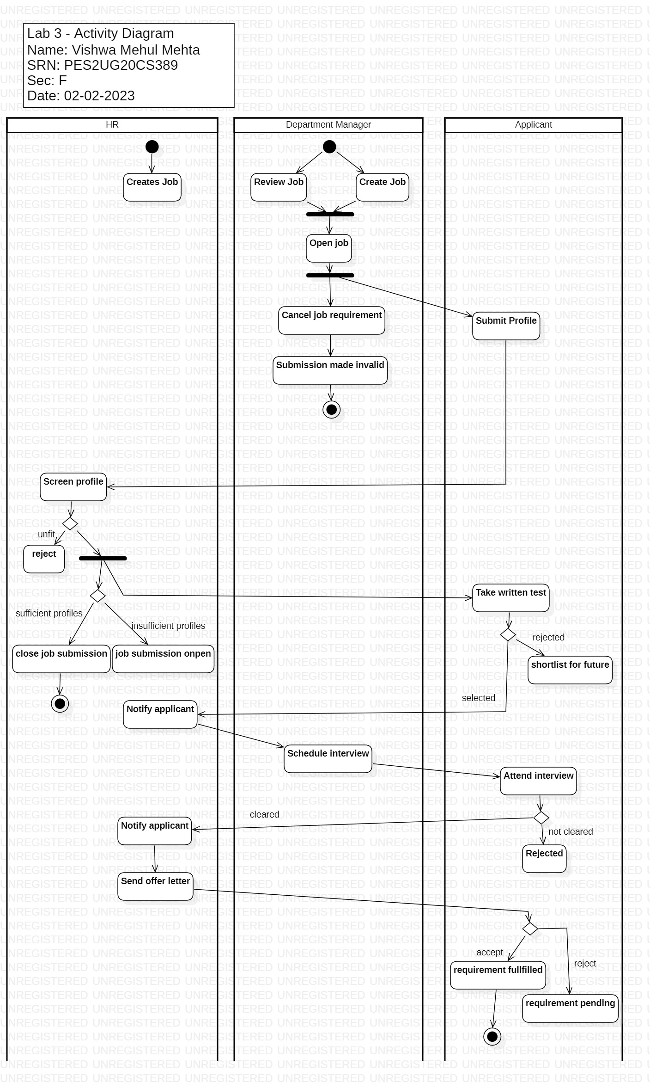

B.

